

**FACULTY OF COMPUTING AND INFORMATION TECHNOLOGY**

Diploma in Software Engineering

Programme: _DCS1__ (Group: ___5___)

**Assignment**

## AMCS1003 SOFTWARE ENGINEERING

|  |  |  |  |
| --- | --- | --- | --- |
| **Name (Block Letters)** | **Registration No.** | **Signature** | **Marks** |
| 1. Tan Kang Hong | 2002959 |  |  |
| 2. Nee Mei Yi | 2003199 |  |  |
| 3. Lau Jun Dian | 2003133 |  |  |
| 4. Har Chun Wai | 2002982 |  |  |
| 5. Cheng Cai Jie | 2003191 |  |  |

Lecturer’s Name: _____________

Date of Submission: ________________



**FACULTY OF COMPUTING AND INFORMATION TECHNOLOGY**

**Plagiarism Statement and Guideline for Late Submission of Coursework**

Read, complete, and sign this statement to be submitted with the written report.

**We confirm that the submitted works are all our own work and are in our own words.**

|  |  |  |  |
| --- | --- | --- | --- |
| **Name (Block Letters)** | **Registration No.** | **Signature** | **Date** |
| 1. Tan Kang Hong | 2002959 |  |  |
| 2. Nee Mei Yi | 2003199 |  |  |
| 3. Lau Jun Dian | 2003133 |  |  |
| 4. Har Chun Wai | 2002982 |  |  |
| 5. Cheng Cai Jie | 2003191 |  |  |

# **Table of Contents**

# **Part 1**

## 1.1 Introduction

J&T Express is an Indonesian logistics company. Founded in 2015, the company is generally engaged in logistics and package delivery. J&T uses automated sorting warehouses in Indonesia and Singapore. It received Indonesian Top Brand Award in 2018 and 2019. As of June 2017, it was valued at 543 million dollars.

J&T Express provide fast pick-ups and delivery services. J&T Express's tagline "Express Your Online Business" positions brand as the core of e-commerce express. Their sustainability in implementing advanced IT management system improves the world express delivery services and customer service qualities with fastest, most convenient and efferent claims. As of now, the J&T Express currently has more than 4000 offices, 3000-drop point, 200 gateways with large distribution equipment and more than 50 000 employees.

## 1.2 Problems of Existing System

* Human error.

In terms of logistics, manual analysis and coordination by employees are very time-consuming and laborious tasks, so certain amount of human error is prone to occur. This may cause delays on the delivery of the package. However, the software solution can process data without errors and can operate without delay.

* Lack of automation function.

In case of functions such as creating transportation routes, loading plans, and assigning goods to carriers were operated manually, some errors made by the employees may occur, this may affect the image of the company and also the customer’s experience.

* Delivery information

Customer hard to find their delivery information at all times. Customers want to be able to know the delivery location completely transparently at all times. Provide 24-hour customer service to reduce customer errors caused by transportation.

## 1.3 Software Quality attributes of the project

* Efficiency

The performance shows the capability of the system in the form of responsiveness to certain operations within a specified time to measure in term of the time required to complete the task given by the system. If the system is using all the available resources, the user will get degraded performance failing the system for efficiency. The efficiency is mainly responsible for the system to continue operating within a predetermined time. A good performance of the system can reduce human error as well as reduce the dependence on manpower and the items can be delivered within the agreed time. The system with a great performance could also contribute in increasing overall sales. We can deal with systematically to improve the efficiency of company and reduce the loss caused by human error.

* Reliability

Reliability is the most important property of the system. A system also can measure if the product is reliable enough to sustain in any condition. A system which has a quality of being trustworthy could efficiently prevent some accidents, and reduce the chance of items cannot be delivered. In this way, the company can continue to make profits under stable conditions. Besides, the system can be seen as reliable if the system test produces a low error rate. Lastly, we can use different environments and different conditions to verify product reliability.

* Maintainability

Different products should be easy and effortless to maintain. The system shall be uncomplicated to add codes to the existing system, so that the new features and mechanics can be applied to the system anytime. The system maintenance should be cost-effective, so that it is easy to correct errors or bugs or make some changes to the software. Packaging of components such that they can be repaired through remove and replace actions rather than on-board repair.

* Integrity

Security is responsible for prevent unwarranted access to system functions as well as defend the privacy of data entered into the system. A system with a good security can keep the customer’s items as much as possible and deliver it to the destination safely. At the same time, an insurance plan is provided to improve the safety of items. Security is responsible for the system's ability to reduce the possibility of malicious or accidental behavior and the possibility of information being stolen or lost.

## 1.4 Software Process Model – RAD model

The Rapid Application Development model (or RAD model) is a development model that prioritizes rapid prototyping and rapid feedback in a long development and testing cycle. Through rapid application development, developers can quickly iterate and update software multiple times without having to start the development schedule from scratch each time. The RAD model was firstly proposed in the 1980s by IBM, so it’s definitely nothing new. But unlike the waterfall model, it is not single. According to the requirements of a specific time, this is the continuous development of the development concept. Initially, rapid application development took the form of a spiral model, where one or more development models are used for specific projects. Though the RAD model appeared during the 1980s, it has evolved ever since. It adapted to the needs of the time, while retaining some core development guidelines.

**1.4.1 Justification**

The RAD model is the most appropriate process model for the proposed system is because it is used to build a product that can be modularized in 2 or 3 months, which is faster compared to other process models.

Compared with other software process models, the RAD model is relatively cheap, but in some cases, it could be expensive. Hiring talented software developers means you need to give them an appropriate salary. On the bright side, if you have them, you can go from idea to final product idea faster than other models.

If the deadline is tight, the RAD model is the best option. If you are under pressure to deliver a workable product, then choosing the RAD platform may be the best choice. If you do not have time for lengthy requirements planning and design phases, then rapid application development software is your best choice. Rapid application development uses a dynamic approach, which makes sense for rapid development because it can change direction quickly.

**1.4.2 Advantages of RAD model**

* It is useful when you have to reduce the overall project risk

Although most of the RAD model focuses on speed and user involvement of RAD done correctly by risk reduction. The RAD model can focus on the key risk factors in advance and adjust to them based on reliable evidence collected in the early part of the process.

* Quicker delivery and high quality

The RAD model involves highly skilled and efficient developers, as a result the project can be finished on time and a quicker delivery could be possible. These developers also ensure a better quality on the product by involving users in the whole life cycle. Users can review each prototype used during the process which helps in identify any issues.

* Flexible and adaptable to changes

The RAD model makes it easier for users to suggest some changes to be made before the final product. The product can adapt quickly to problems and opportunities, and also can change requirements at any time throughout the process.

**1.4.3 Disadvantages of RAD model**

* Too dependent on highly skilled developers

The personnel involved in the RAD project are too dependent, and even one of them cannot fully perform the task, which may affect product development.

* Needs user requirement throughout the life cycle of the product

Because the RAD process involves customers from the beginning of the product life cycle. If there are no customers available or quick decisions cannot be made at important decision moments, it may affect the quality and speed of product development.

* Needs strong team collaboration

The RAD process encourages a small team (approximately 2 to 6 developers). At the same time, the developed products require high quality and high speed. To achieve this goal, all members of the team must be very proficient and familiar with the tools used, which is crucial.

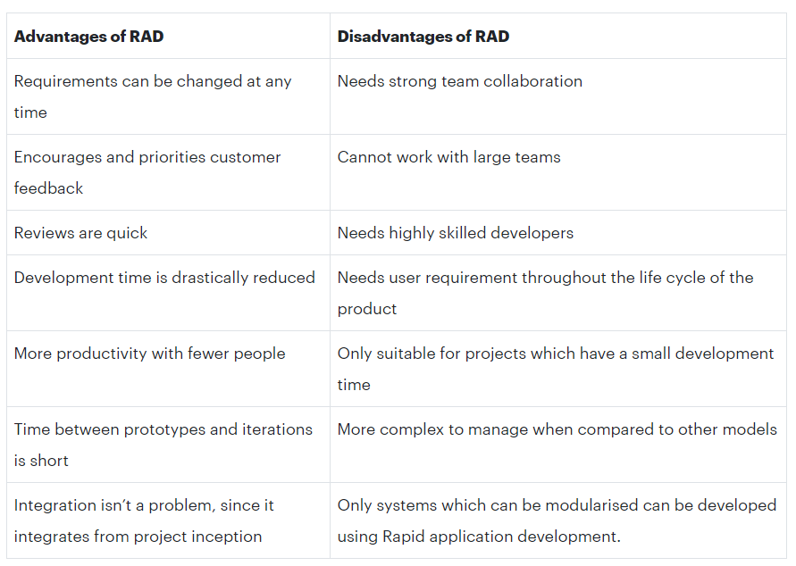

|  |  |
| --- | --- |
| **Advantage** | **Disadvantage** |
| Flexible and adaptable to changes | It can't be used for smaller projects |
| It is useful when you have to reduce the overall project risk | When the technical risk is high, it will not be suitable for the system. |
| Due to prototyping in nature, there is a possibility of lesser defects | Due to the limited time, the functions that can be used in a standardized way are reduced, and the function must be released in a short period of time if the function is upgraded to a higher version |
| In the case of fewer people, to achieve a short-term increase in productivity | Progress and problems are difficult to retrieve because there is no documentation to prove the work done |
| Each stage of RAD focuses on the client and provides the highest priority functions | Developers need to deliver software on time in a short time, otherwise the RAD project may end in failure. |

**1.4.4 Phases of RAD model**

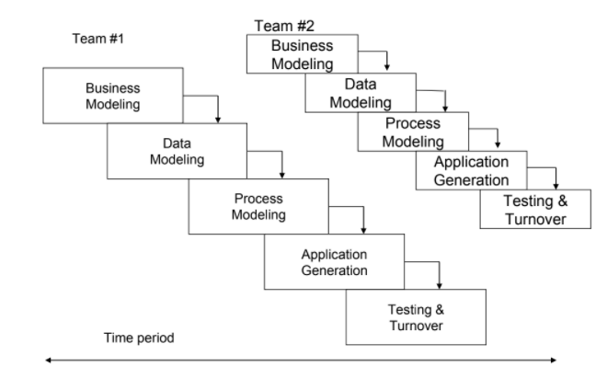

Diagram 1.1 Phases of RAD model

Phase 1: Business modeling

The business modeling step in the RAD model obtains information from company information collected through many business-related sources. This information is then combined into a useful description to explain how the data is used when processing the data, and the reasons for the success of that particular information in the industry. During this phase, it is possible to get a complete picture of business process functionality. Some of the common deliverables are produced in this phase including project definition, project management procedures, and work plan.

Phase 2: Data modeling

In the data modeling phase, all the information collected in the business modeling phase will be analyzed. Through analysis, information can be divided into different groups, which is useful for companies. The quality of each data group has been carefully checked and an accurate description is given. At this stage of the RAD model, the relationship between these groups and their usefulness will also be defined in the business modeling step. These models are used to aid logistics managers in their attempts to design system to cope with the future. In some situations, exact classification of individual model along these two dimensions can be difficult.

Phase 3: Process modeling

The process modeling stage is a step in the RAD modeling process, where all the information groups collected in the data modeling step will be converted into the required usable information. In the process modeling stage, changes and optimizations can be made, and the data set can be further defined. At this stage, any descriptions about adding, deleting or changing data objects will also be created.

Phase 4: Application generation

The "application generation" step is to encode all the information collected and then build the system that will be used to create the prototype. The created data model will be transformed into an actual prototype, which can be tested in the next step.

Phase 5: Testing and Turnaround

The testing and turnaround phase can reduce the overall test time for creating a prototype. Each model is individually tested to quickly identify and adjust components to create the most effective product. Since most of the elements have been checked before, there should be no major issues with the prototype.

**Part 2**

**2.1 Project Plan and Schedule**

Task Allocation list and Gantt Chart are available in Excel File:

<https://onedrive.live.com/view.aspx?resid=3074BFCAF65A538B!11798&ithint=file%2cxlsx&authkey=!AJFGhS7gZlP4MK8>

**2.2 Software Requirement Specification**

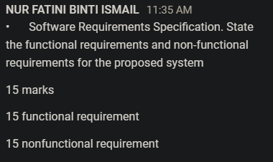

functional req.: what who when

**2.2.1 Functional requirements**

**Customer**

1. The system should allow customers to register their J&T ID before they can access to member-only contents in the J&T Express’s website or mobile app.

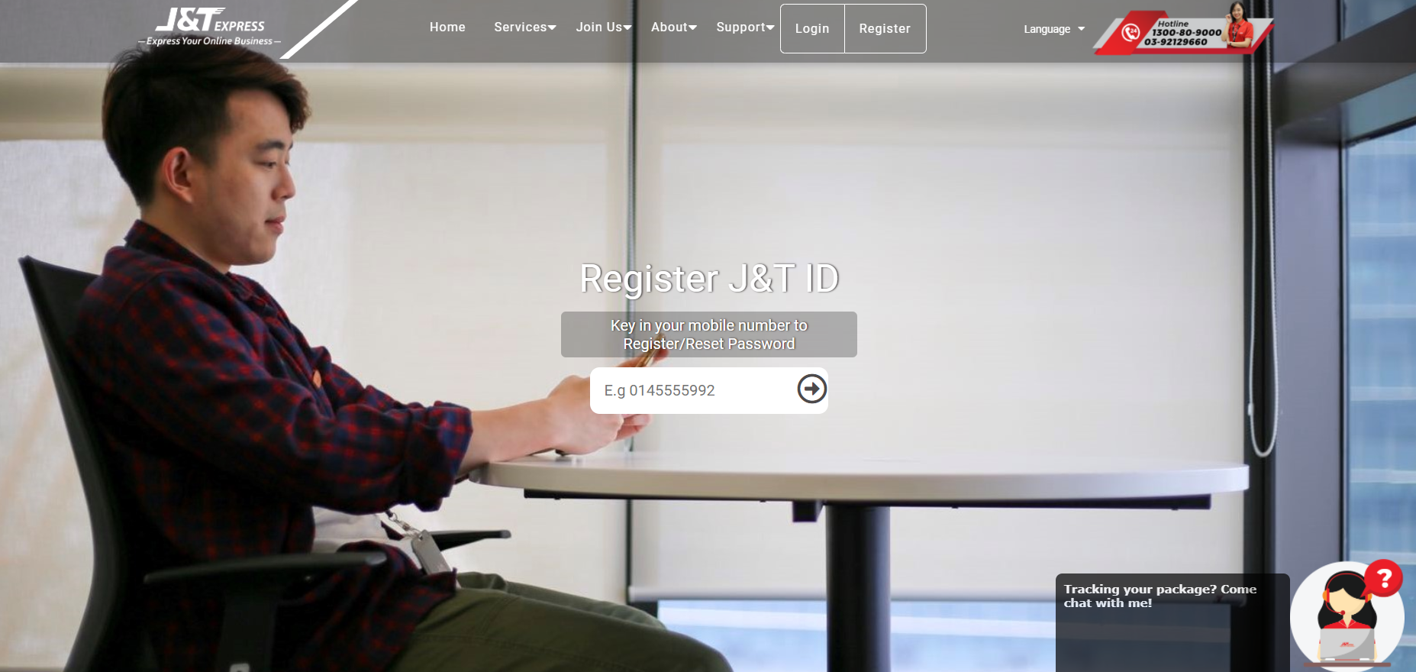

The register screen which needs customer to input the phone number

2. The system should allow customers to login with their username, e-mail or phone number and the password when the customer wants to access ??

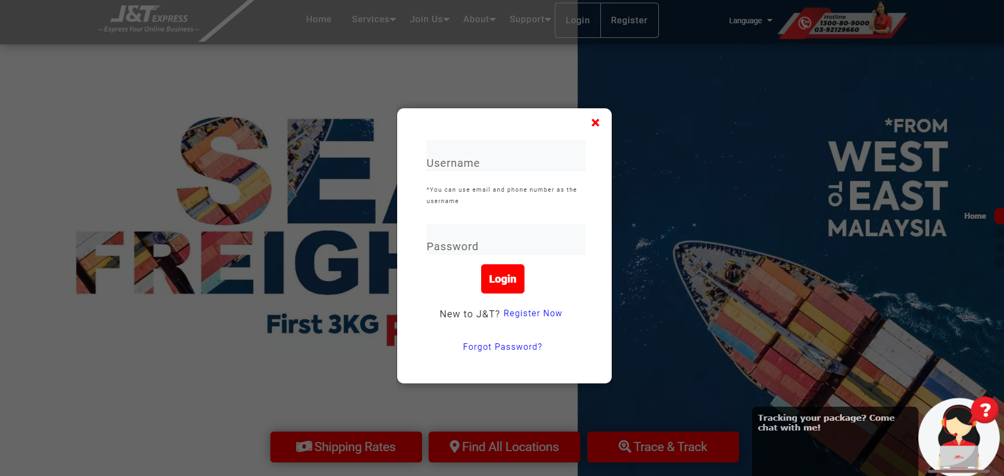

Login screen

3. The system should display the order page so it can allow customers to place their order when they want to create an order.

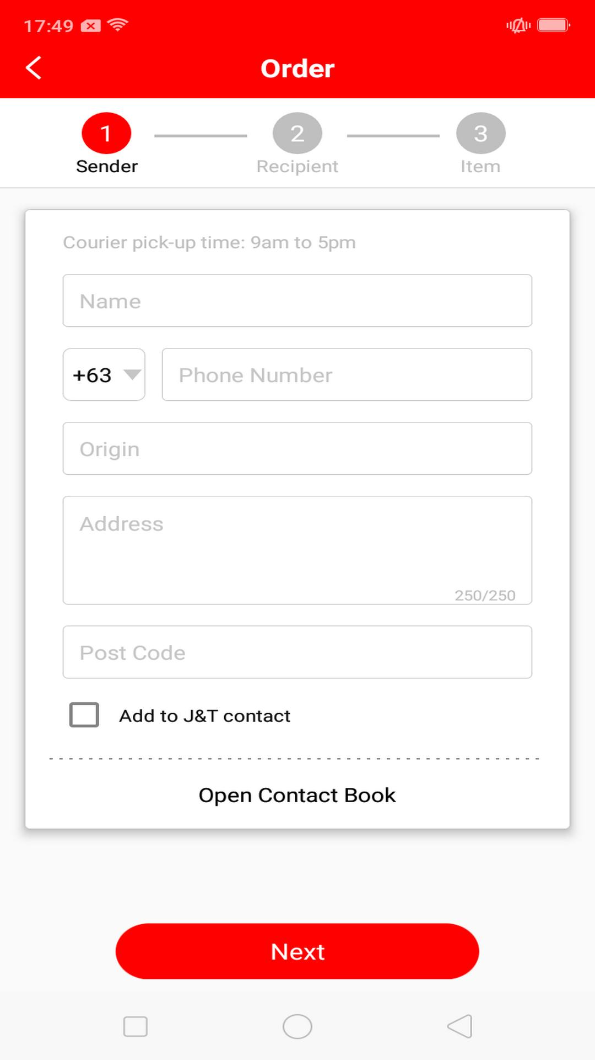

A create order screen in the mobile app

4. The system will display the order details and prompts the customer to confirm the amount before they start to make payment.

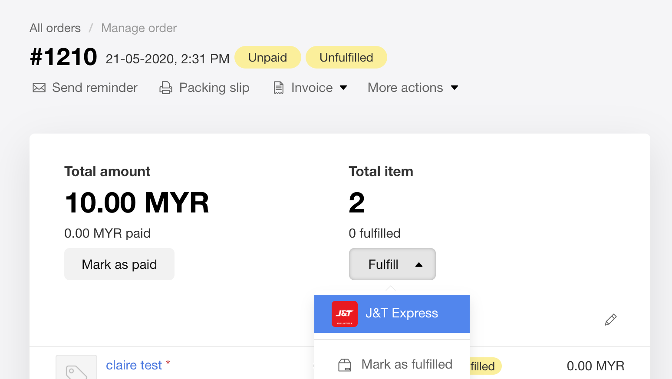

An order payment screen in the website

5. The system will send the customer the verification email to confirm that they have ordered it by them self when they want to make a payment.

6. The system will generate a receipt to the customer via e-mail after the order have successfully done by the customer.

7. The system should allow customers to check the estimated delivery time provided when the customer’s order is sent for delivery.

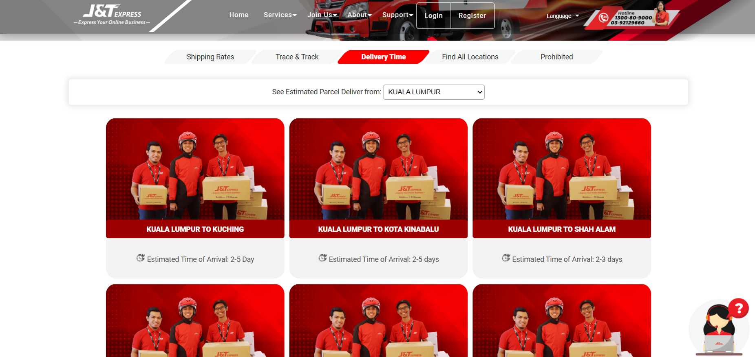

The screen of the estimated delivery time from Kuala Lumpur

8. The system should allow customers to trace and track their order by typing their airwaybill number when the customer’s order has been shipped.

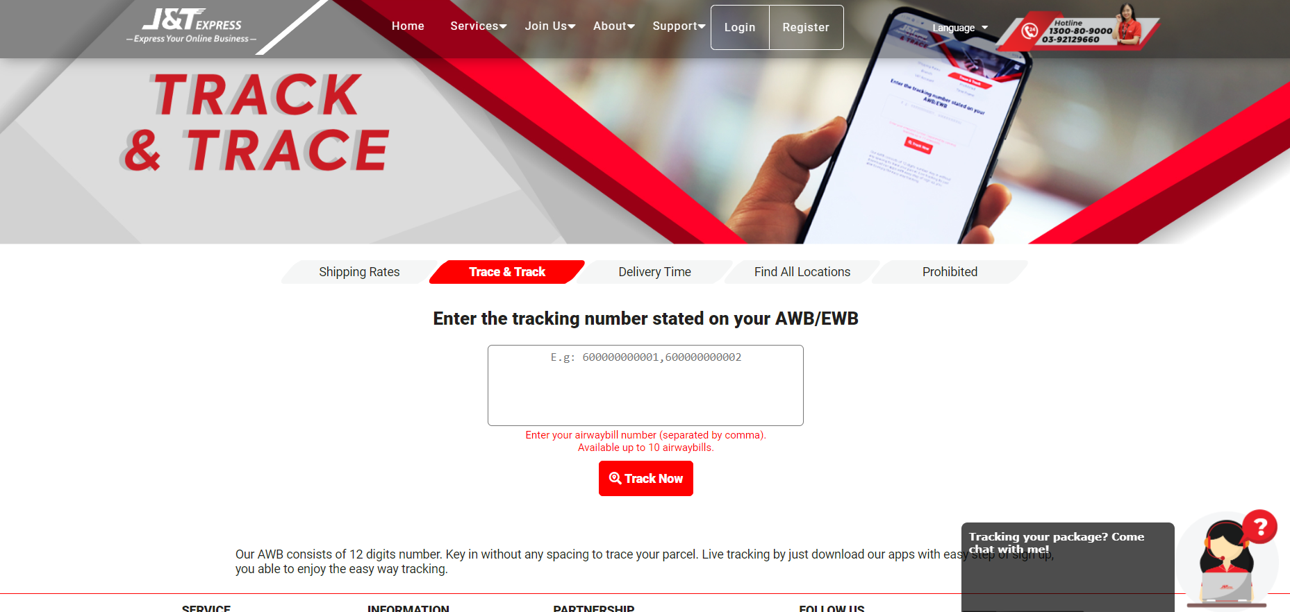

Trace and Track screen

9. The System should send an e-mail to the customer to remind them that the parcel has arrived at its nearest J&T branch and is ready for delivery.

10. The system should allow the customers to send feedback about the J&T Express via contacting the service so the company can have the opportunity to improve it.

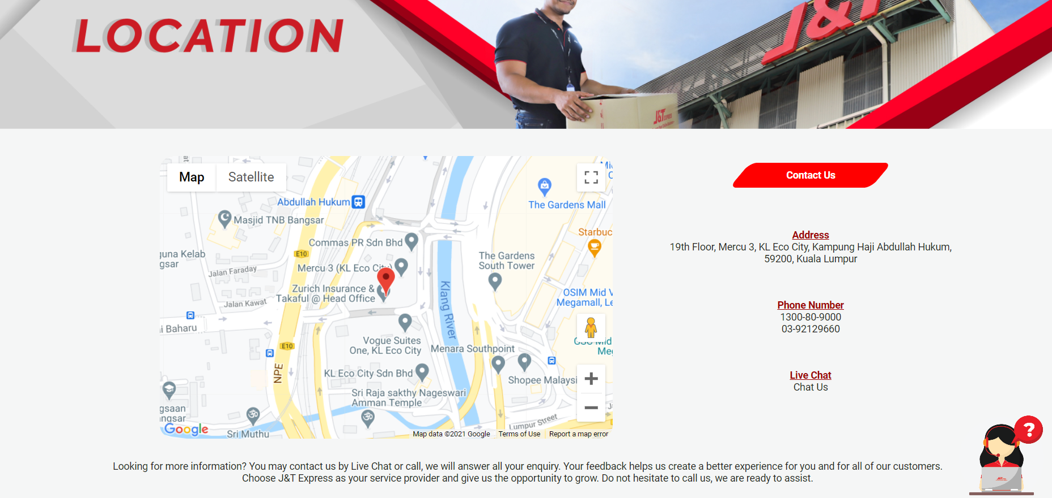

The “Contact Us” page allowing customers to know where to contact the J&T Express service

**Administrator**

11. The system will send the ordering page to staff, where the staff have to confirm the customer’s order before they can pass it to the payment department.

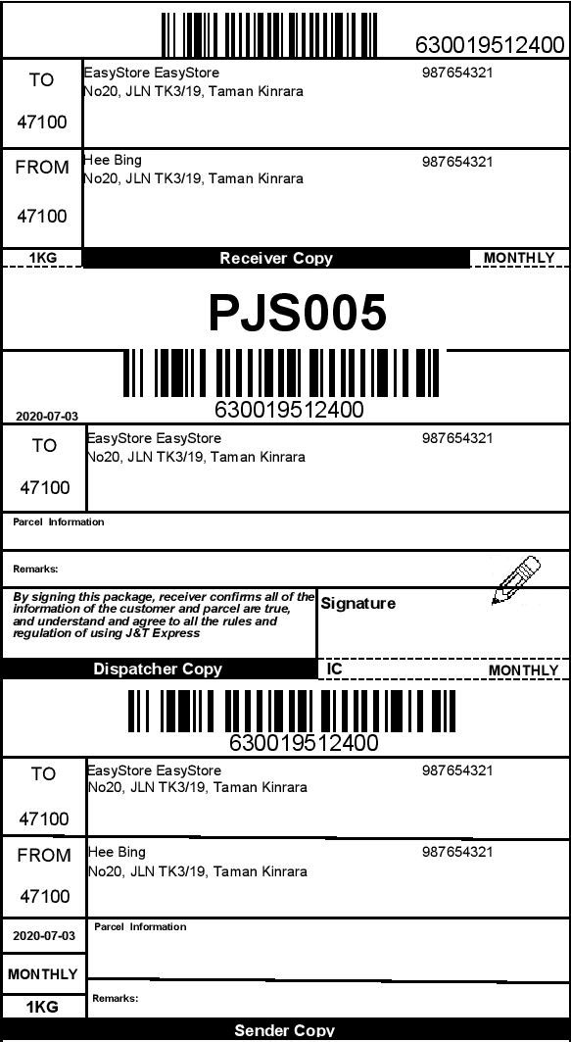

The order payment screen

12. The system will save all the payments made by the customers so they can check their payment history whenever they want after the customer made the payment.

13. The system should check the delivery items that have been ordered by the customer to ensure that the staff didn’t messed up with other ordered items before they made their checking and pass it to the delivery department.

14. The system will arrange the ordered items by the location for the staff’s convenience in delivering items.

15. The system should collect customer’s feedback so the company can have the opportunity to improve their quality from time to time.

non-functional req.: how (based on software quality attributes)

**2.2.2 Non-Functional requirements**

1. The system should allow the customers to “update the client” during 98% of normal working hours.

2. The system can evaluate whether the current system meets the performance and requirements of various aspects through scalability to achieve the maximum workload.

3.The system should define the estimated duration to fix the system and upgrade it to increase the overall performance so that it can be adapted to a changing environment.

4. The system must have a function that can address a simple question and define the requirements needed.

5. The system should be able to handle the error to avoid that if the user accidentally cancels or exits the "update customer" process, the changes made by the user will be undone.

6. Only users with the role of "Customer Advisor" or "Supervisor" can access the "Update Customer" function (example: Only users with the role of "Supervisor" can update the customer's date of birth).

7. During the "Update Customer" process, the system’s response should not exceed 1 second.

8. The data change time must be recorded to the nearest second.

9. The system can provide nearly 300 users at the same time to use the "update customer" function at the same time.

10. All system components must follow a common and standard set of exchange formats to exchange data; the lack of interoperability happens when people do not follow standards.

11. Maintaining and assuring data accuracy and consistency is the function that can't have the error for a system.

12. The system must follow a common and standard set of exchange formats to exchange data so that the lack of interoperability when people do not follow standards won’t happen.

13. Make the system able to process large amount of data and store it safely at the same time.

14. Have a multiple language option so that everyone can use it. For example, English, Chinese, Malay and other more.

15. The system must have the ability to recover the crash or failure in the system and return to full operation.

**2.3 Architectural design**

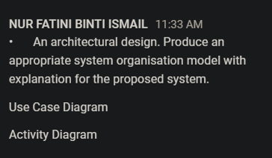

**Need to draw both two diagrams**

**2.3.1 Activity Diagram**

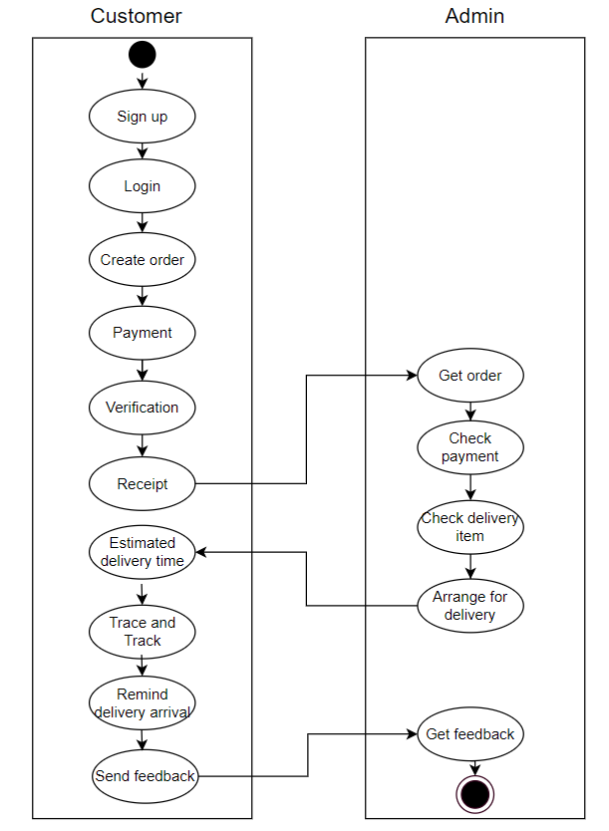

**2.3.2 Case Diagram**

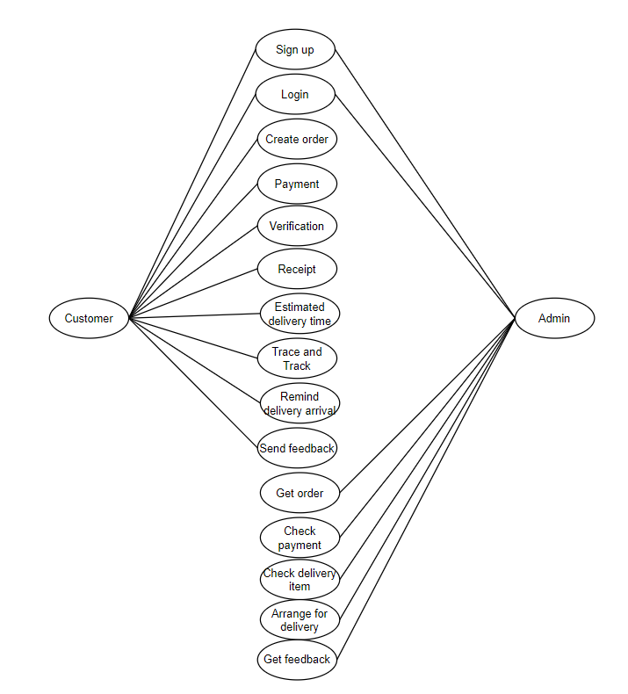

(Examples ONLY):

<https://drive.google.com/file/d/1mErynlFXUF8bDcqXEUurxtw9xa3cp8WA/view?usp=sharing&authuser=1>

<https://drive.google.com/file/d/1tZT4aMtpeDm9jatuBGKKSRZaE7Ogs441/view>

References: (Draft, 上网找的link可以放这里，要写下日期)

**1.1 Introduction**

<https://www.jtexpress.my/index.php> - 29/1/21

<https://en.wikipedia.org/wiki/J&T_Express> - 29/1/21

**1.2 Problems of Existing System**

<https://www.logisticsmgmt.com/article/top_8_logistics_challenges_facing_the_industry> - 29/1/21

<https://medium.com/swlh/logistics-software-the-major-key-to-solve-your-supply-chain-issues-3fc5ca6fb0a8> - 29/1/21

**1.3 Software Quality attributes of the project**

<https://syndicode.com/blog/12-software-architecture-quality-attributes/> - 5/2/21

<https://www.softwaretestinghelp.com/what-are-the-quality-attributes/> - 5/2/21

<https://www.softwaretestingmaterial.com/quality-attributes-in-software-architecture/> - 5/2/21

## 1.4 Software Process Model

<https://hackr.io/blog/rapid-application-development-model> - 15/2/21

<https://www.guru99.com/what-is-rad-rapid-software-development-model-advantages-disadvantages.html> - 15/2/21

<https://kissflow.com/rad/rapid-application-development/> - 15/2/21

<https://en.wikipedia.org/wiki/Rapid_application_development> - 15/2/21

<https://kissflow.com/rad/benefits-of-rapid-application-development/> - 15/2/21

https://artoftesting.com/rad-model - 16/2/21

<https://theappsolutions.com/blog/development/rad-model/> - 16/2/21

<https://www.hokuapps.com/blogs/rapid-application-development/> 16/2/21

**2.2 Software Requirement Specification**

<https://scmwizard.com/functions-of-logistics/> - 3/5/21

<https://www.altexsoft.com/blog/non-functional-requirements/> - 3/5/21

<https://jelvix.com/blog/functional-vs-nonfunctional-requirements> - 3/5/21

<https://aakashtechsupportdocs.readthedocs.io/en/latest/nonfunc.html> - 3/5/21

<https://reqtest.com/requirements-blog/functional-vs-non-functional-requirements/#:~:text=What%20are%20those%2C%20and%20how,what%20the%20system%20should%20do.> - 3/5/21